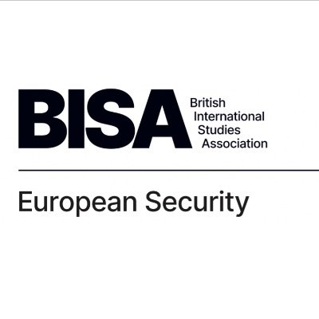

BISA European Security Working Group
5th Workshop, 18th February 2021
Programme

‘Multilateral Security Cooperation Under Stress’

Welcome

Panel 1: NATO and multipolarity Chair: Nele Marianne Ewers-Peters
9:50am - 10:00am

10:00am - 11:15am

Cornelia Baciu (IFSH Hamburg) & Domenika Kunertova (ETH Zurich)
Progressive Grand Strategy, Co-Relational Power and Geopolitical Dilemmas: NATO and the EU in an Era of Great Power Competition

Andrew Cottey (University College Cork)
NATO and the China Challenge

Leon Schütte (Maastricht University)
International Organisations Under Hegemonic Contestation: NATO's Strategic Responses to Trump

Feyyaz Baris Celik (University of Kent)
National strategies within the operational overlap between the EU and NATO

Coffee break

Panel 2: The EU’s internal security crises and Brexit
Chair: Antonia Niehuss
11:15am - 11:30am

11:30am - 12:45pm

Lorenzo Cladi (University of Plymouth)
Keeping it balanced: Multipolarity and European Security Cooperation after Brexit

Arantza Gomez Arana (University of Northumbria)
Gibraltar and Brexit: a different approach for the other border?

Helena Ferrand Carrapico (University of Northumbria), Karolina Augustova (Aston University) & Jelena Obradovic-Wochnik (Aston University)
'Governing (Im-)Mobilities': from EU Violent Border Protections to Smuggling

Bárbara Campos Diniz (PUC Minas)
Contemporary Terrorism and Counterterrorism Dynamics in the European Union

Lunch break
12:45pm - 1:30pm

Panel 3: Technology and European defence capability
Chair: Jocelyn Mawdsley
1:30pm - 2:30pm

Silvia Grant (Aston University/MoD)
UK, Hybrid Warfare and the Digital Foundry

Francesco Giumelli & Mustafa A. Sezal (University of Groningen)
Consolidation of the Defence Sector and Technology Transfer in the EU: Lessons Learned From the Netherlands

Simon Sweeney (University of York) & Neil Winn (University of Leeds)
Understanding the Ambition: What is the Strategic Compass about, what should it be about?

Coffee break

Keynote
Chair: Andrew Cottey

Mark Webber (University of Birmingham)
‘What’s Wrong with NATO and How to Fix It’

Final reflections and thank you

2:30pm-3:00pm

3:00pm – 4:00pm

All times are in Greenwhich Mean Time (GMT).

The workshop is open to anyone interested in joining. Presenters, chairs and participants need to be either BISA members or can join as non-BISA members but need to pay small fee to BISA. Please find further information here.

