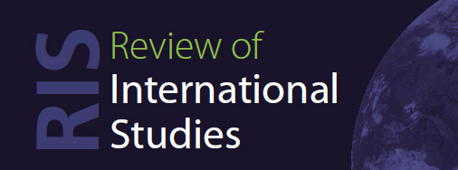

Review of International Studies Workshop for Women Early Career Researchers

Application Form

Name:

Institution (if applicable):

Date and Institution of Your PhD:

Title of Draft Paper:

What is the main aim or argument of your paper? [You may include a full abstract, but it is not necessary to do so.] [max 300 words]

How would you benefit from participation in the workshop? [max 300 words]

Have you submitted to journals before? If so, which ones?

If selected, would you be willing to comment on another participant’s paper? [We think that you can learn much from doing this, but we will not disadvantage applicants who are unable to contribute to this aspect of the workshop.]

Please confirm that you consent to your paper being shared among editors of the Review of International Studies and fellow workshop participants for the purposes of providing feedback at the workshop.

