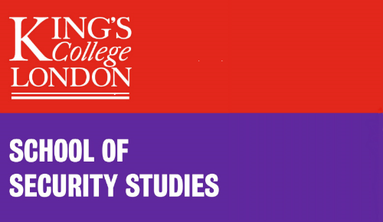

BISA Global Nuclear Order Working Group Annual Conference 2021

Reassessing Key Debates in the Nuclear Field

King’s College London
02-03 December 2021 (online)
Programme

Day 1 Thursday 2 December 2021

12.00 Welcome from BISA GNO, update on working group activities

12.15-1.55pm Panel 1: Reassessing uncertainty and stability as core nuclear concepts
(Chair: Laura Considine)
- James Johnson - Inadvertent Escalation in the Age of Intelligence Machines: A new model for nuclear risk in the digital age.
- Artur Honich - The Overlooked Pillar of U.S. Missile Defense: Assessing the Conceptual Issues with ‘Left-Of-Launch’ Operations.
- Henrietta Wilson - Verification: How Much is Too Much? Can Open Source Research Revolutionise Nuclear Nonproliferation and Disarmament?
- Robin Vanderborght - Strategic stability as a social construct: how international practices produce an ever-evolving understanding of one of the nuclear field’s core concepts.
- Fabian Hoffmann - Reconsidering Conventional-Nuclear Integration: From Capability to Function.

2.00-3.30pm Panel 2 - Rethinking deterrence and the nuclear future
(Chair: Patricia Shamai)
- Lyndon Burford - At the nuclear Hotel California: the prison of nuclear deterrence.
- Paul Schulte - "New (?) Terminology in The Moral and Strategic Debate over the Nuclear Future.
- Aylin Matle - The possible merits and pitfalls of a sole purpose policy for NATO.
- Kjølv Egeland - The “Cosmic Bluff” Revisited. Extended Nuclear Deterrence in the U.S.–Norway Alliance.

3.30-3.45pm Break

3.45-5.30pm Panel 3 - Strategy, culture and identity in the nuclear state
(Chair: Nicola Leveringhaus)
- Geoffrey Chapman - Sub-strategic Trident: Material Change or Mirage?
- Emily Ferris and Luba Zatsepina - Russian Strategic Culture: Implications for Arms Control Futures.
- Thomas Fraise - Democracy, secrecy and the nuclear state: how do nuclear weapons affect democratic states?
- Tim Street - Nuclear disarmament: democratise or perish?
- Ann George - Constructing the China threat: the Indian strategic community's interpretation of Chinese HGV tests.

5.30pm End of Day 1

Day 2 Friday 3 December 2021

9.15-9.30am Welcome back

9.30-11.00am Panel 4 – Narrative, discourse and gender as means to rethink the nuclear world (Chair: Patricia Shamai)
- Laura Considine - Narrative and nuclear weapons politics: the power of the nuclear origin myth
- Benoit Pelopidas - Imagining the possibility of nuclear war to confront it. The role of fiction since 1950.
- Carolina Panico - Less violent and more responsible possessors? The role of disarmament discourses in upholding the nuclear status quo.
- Abhishek Sharma – Engendering the negotiations on nuclear disarmament: locating and analysing the gender element in the negotiations.

11.00-11.15am Break

11.15-12.45pm Panel 5 – Contextualising approaches to nuclear disarmament
(Chair: Rhys Crilley)
- Ramesh Balakrishnan - The US "Creating an Environment for Nuclear Disarmament (CEND)" disarmament initiative and the prospects for global nuclear disarmament.
- Joelien Pretorius - Situating the Nuclear Ban Treaty in the context of outlawing war.
- Tobias Vestner - Treaty law to signal to outsiders: The case of the Treaty on the Prohibition of Nuclear Weapons.
- David Morales - The impacts of the Treaty on the Prohibition of Nuclear Weapons and its contributions to the Nuclear-Weapons-Free Zones.

12.45-1.00pm Closing remarks

All are welcome to join. Please register for the event at: https://www.bisa.ac.uk/members/working-groups/gno/events/reassessing-key-debates-nuclear-field

