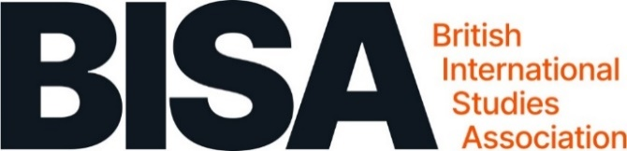

Expenses claim form
Once complete please email this form, along with all receipts (to include VAT where applicable), to: office@bisa.ac.uk
General
Event details:
Dates: |  |  | From: |  | To:
Applicant (Please complete all fields)
Title |  | Mr □ Mrs □ Miss □ Ms □ Dr □ Prof □
First name
Surname (family name)
Home address (incl postcode):
Email address
Telephone number
Claim details:
Date | Details |  |  |  | Amount | Currency
Total expenses
Amount awarded (office use only)
Payment details (Payment will be made by bank transfer)
Name of account holder:
Bank name:
Bank address:
Sort code: |  |  |  | Account number:
Overseas payments: BIC No: |  |  |  | IBAN No:
ABA/Routing no: |  |  |  | Currency of account:
Signature |  |  |  | Date

Notes
- All claims must be submitted within one month of the event to which the expenditure incurred relates.
- Please attach VAT receipts where applicable
- Consideration must be made to using the most cost effective method of travel:
- only standard class travel should be booked
- if travelling by car the total claim for any journey made must not exceed the standard class rail fare.
- By signing this form, I confirm that I have not claimed any of these expenses before and will not claim them from any other source

