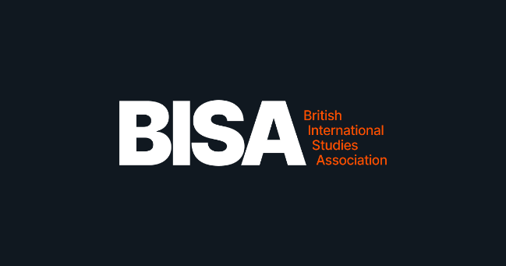

Global Nuclear Order Working Group Annual Conference 2024
Friday 22 March (online via Zoom)

*Please note, all timings are in UTC/GMT
Introduction  10:00-10:15 | GNO Convenors
PANEL 1  10:15-11:45 | Contesting Nuclear Hierarchies: The Global South, Re-Humanising Threats, and Highlighting Problematic Notions of Governance
Chair: tbc

Convergence and Contestations in Nuclear Proliferation Regime: Articulating Global South Perspectives
Shalini Prasad (University of Allahabad)

Nuclear Power and Systemic War: Substrategic Considerations with Existential Implications
Rhys Lewis-Jones (University of Cardiff)

How to Justify Inaction: Dealing with Nuclear Remnants and Injustices
Jana Baldus (Peace Research Institute Frankfurt)

The Face of the ‘Technical’: How the IAEA Silences Nuclear Disarmament and Naturalises NPT Hierarchy
Felicia Yuwono (King’s College London)

11:45-12:15 | Lunch (Q&A with GNO convenors)
PANEL 2  12:15-13:45 | Challenges to a Peaceful Nuclear Order: Nuclear Norms, Treaties, and Security Threats
Chair: tbc

The NPT and the TPNW: Comparison and Prospects for Arms Control, Non-Proliferation, and Disarmament
Cornelia Hedløy (Norwegian Embassy in New Delhi)

The TPNW and the EU Neutrals: Reconciling Alignment and the Ban
Valentina Cassar (University of Malta)

Global Governance of Arms Control and Peaceful Nuclear Order
Asia Maqsood (University of Management and Technology)

The Making and Maintenance of Extended Nuclear Deterrence: A Critical Discursive Approach to an International Security Policy
Konstantin Schendzielorz (University of St. Gallen)

Delegitimising Disarmament: Reactionary Rhetoric in Non-Proliferation Discourses
Thomas Fraise (Massachusetts Institute of Technology)

13:45-14:00 | Break
PANEL 3  14:00-15:30 | Taking Stock of Alternatives: Pop Culture, Populism, and Disruptive Challenges in Nuclear Politics
Chair: tbc

Nuclear Ethics and Nationalism: An in-depth Scrutiny through a Pop-Culture Lens
Hely Desai (University of Cambridge)

Populist Publics’ Affinity for Nuclear Weapons? A Contextual Theory Explaining Opposition to the Nuclear Sharing Weapons in European Populist Publics
Tom W. Etienne (University of Pennsylvania), Michal Onderco (Erasmus University Rotterdam), Sandra Destradi (Reichman University/University of Freiburg), André Krouwel (VU University of Amsterdam)

Disruptive Diplomacy: Situating Multilateral Disarmament Diplomacy in the Changing Global Order
Anahita Parsa (BASIC)
15:30-16:00 | Concluding remarks

