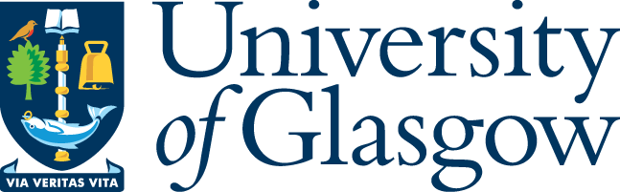

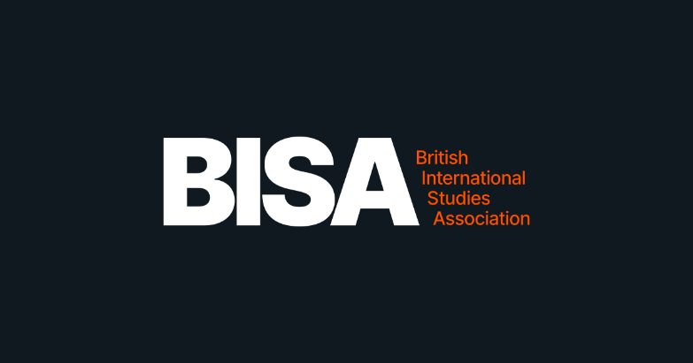

Un-siloing Pedagogy and Research: Intersecting Harms and Risks in International Security
BISA Global Nuclear Order Working Group & Atomic Anxiety Project
University of Glasgow
Advanced Research Centre (ARC): Studio 2
Tuesday, 26 May | 09:30–17:30

09:30–10:00 – Welcome Coffee & Opening Remarks (Rhys Crilley and Tom Vaughan)

Arts, Heritage, the Everyday & Nuclear Pedagogy

10:00–11:00 – Featured Activity
Tim Peacock (University of Glasgow)
Dial N for Nuclear - 'Ringtone' Variant

Mystery meets Nuclear Diplomacy! Who knows what secrets? Is there a Motive? What actually happened? Engage in a taster 'Ringtone'version of this discussion-based gaming exercise, set in the real-world, used in classes, research and engagement events since 2024. No previous experience or added technology required, only curiosity, navigating the clues of an unfolding nuclear diplomatic crisis.

11:00–11:15 – Coffee Break

11:15–12:45 – Lightning Talks & Discussion

Chair: Laura Rose Brown

Panellists: Franco Escobar (Keele University) & Chaeyoung Yong (University of St Andrews)
Everyday Encounters, Representation, and Memorialisation
Guiding questions:
- How can culture-led and everyday approaches to teaching and learning create meaningful impact opportunities in international security and nuclear politics?
- How can classroom experiences be better integrated into research design, impact strategies, and knowledge production?
- What do everyday encounters and memorial practices reveal about intersecting harms and risks in nuclear politics?
(Format suggestion: 2 × 12–15 min lightning talks, followed by extended facilitated discussion)

12:45–13:45 – Lunch

13:45 – 14:45 Featured Activity
Ioana Popescu (University of Edinburgh)
Arts-Based Methods and Nuclear Pedagogy
How can arts-based methodologies, such as collage-making, creative actor mapping, and Theatre of the Oppressed, deepen analytical engagement with complex socio-political issues, risk, and harm in international security?

Futures, Transdisciplinarity & Pedagogy as Research

14:50–15:30 – Featured Activity
Declan Penrose (University of Manchester)
Foresight Methodologies, Nuclear Pedagogy, and Research
What can futures-thinking and foresight methodologies contribute to nuclear pedagogy, and how can teaching itself operate as a site of research in global politics?

15:30–15:50 – Coffee Break

15:50–17:20 – Lightning Talks & Collective Discussion

Chair: Megan Dee (University of Stirling)
Panellists: Lucas Perez Florentino (Geneva Graduate Institute) & Patricia Shamai (University of Portsmouth)
Teaching the Global Nuclear Order: Elites, Inclusion, and Transdisciplinarity
Guiding questions:
- Is nuclear weapons thinking primarily the product of elites, and how is this reproduced within university teaching?
- How are nuclear weapons currently taught across disciplines, and is this teaching inclusive? Does inclusivity matter for how risks and harms are understood?
- How can nuclear politics pedagogy establish dialogue with other social sciences and the humanities tackling similar issues?
- Should—and how could—transdisciplinarity be reconciled with disciplinary requirements in university curricula?
- How can non-classroom-based approaches (e.g. site visits, creative practice, simulations) materialise the realities of the Global Nuclear Order for students?
(Format suggestion: 2 × 12–15 min lightning talks, followed by structured roundtable discussion)

17:20 – 17:30 – Reflections on the day

18:30 – Workshop Dinner
(Details TBC)

